07th May 2018

YOKOHAMA is Official Tyre Partner to Silverstone Classic

With a history spanning more than 100 years which includes numerous motorsport championship victories and titles, premium Japanese tyre manufacturer YOKOHAMA has become the Official Tyre Partner of the Silverstone Classic.

The event is the world’s largest classic motor racing festival and will see thousands of motorsport and classic car fans from all corners of the world flock to Silverstone Circuit from the 20th – 22nd July for three days of action packed historic motor racing, displays from over 100 car clubs, air displays, live music and a host of other entertainment.

As the Official Tyre Partner, YOKOHAMA will lend its name to several of the festival’s highlights including the YOKOHAMA Trophy for FIA Masters Historic Sports Cars and the YOKOHAMA Silverstone Classic Supercar Track Parade and Paddock Display. Additionally the company will present the YOKOHAMA Silverstone Classic Club Car of the Show Award.
“YOKOHAMA has a rich and successful heritage around the globe in all forms of motorsport so it’s fantastic that we’ll be playing an integral part of this year’s Silverstone Classic festival,” comments David Seward, managing director, Yokohama HPT. “We look forward to seeing some historic racing greats being put through their paces at Silverstone Circuit during the event as well as meeting up with the thousands of fans who will be cheering them on.”
Today, YOKOHAMA supplies tyres to drivers competing in 30 motorsport series in the UK including circuit racing, rally and rallycross. Its tyres are also used in the FIA World Touring Car Cup. However, its motorsport pedigree extends even further having previously secured race honours with competitors in the British and European Touring Car Championships, the 24 Hours of Le Mans, 24 Hours of Spa and the European Formula 3 Championship to name a few.

As well as its highly regarded competition tyres, YOKOHAMA produces a comprehensive range of passenger car tyres which are increasingly fitted by the world’s leading vehicle manufacturers as original equipment. Indeed, vehicles including the new BMW M5 and X3 models, the Mercedes-Benz AMG E43 and the Porsche 911 all now come fitted with YOKOHAMA’s top of the range ADVAN Sport V105 tyre as standard.

The Silverstone Classic is firmly established as the world’s biggest classic motor racing festival. The epic event attracts more than 1,000 race entries and draws crowds of more than 100,000. The spectacular classic car celebration is staged at the famous Silverstone circuit in Northamptonshire, birthplace of the FIA Formula One World Championship.

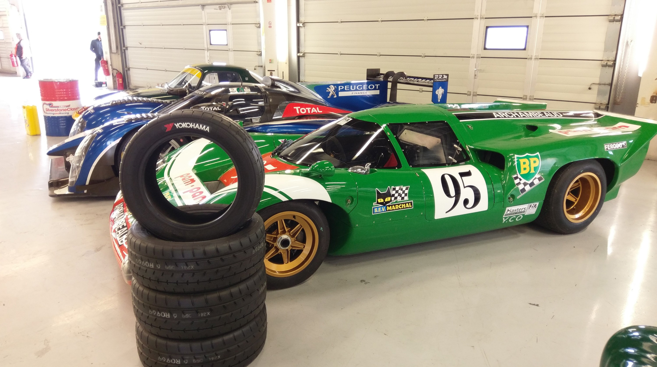
Silverstone Classic media day

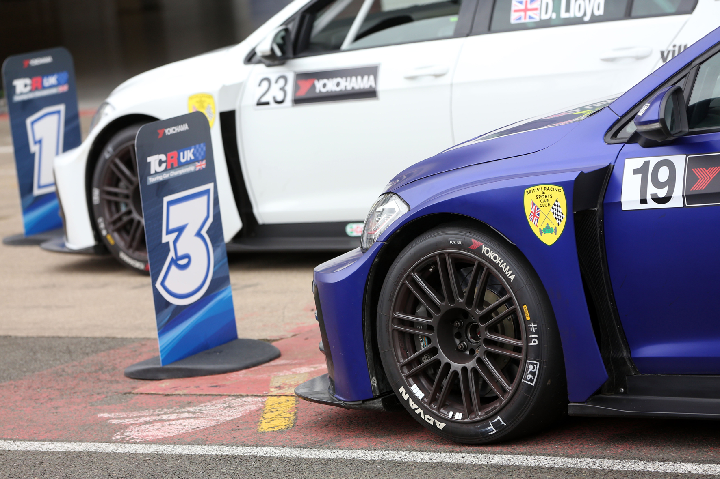
YOKOHAMA 4 HR

